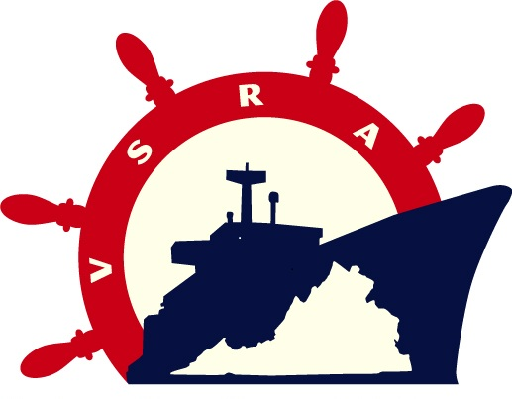
25th Annual
Virginia Ship Repair Foundation (VSRF) Golf Tournament
Tuesday, August 16, 2011

FORMAT: 4-man best ball, Shotgun Start, 18-hole play
PLACE: Bayville Golf Club, 4137 First Court Road, Virginia Beach
TIME: Registration: 10am to 12:30pm……Lunch Begins: 11am…..Tee Time: 12:30pm

Name of Company Sponsoring this group:
Point of Contact Name:
Point of Contact Telephone:
Point of Contact e-mail address:

All proceeds to benefit VSRF, a 501(c)(3) Educational Foundation and are tax deductible.

Choose Level of Sponsorship (all sponsorships include program recognition)
Platinum - $5000 (2 foursomes, mulligans, banner with logo, featured website sponsorship)

Gold - $2500 (1 foursome, mulligans, banner, featured website sponsorship)

Silver - $1800 (2 golfers, banner, featured website sponsorship)

After Golf Social - $750 (company name and logo on pavilion table tents)

Beverage Cart - $750 (small banner)

Lunch Sponsor - $600 (company name and logo on boxed lunch)

Hole Sponsor- $500 (signage)

Longest Drive - $400 (signage)

Closest to Pin - $400 (signage)

Individual Player - $300 - Total number of Individual Players:

Hole 9 Yard Package - $40 individual/each $160 team

Purchase in advance! NOTE: Package is $50 day of tournament
Includes (2) mulligans, (2) 50/50 raffle tickets, (8) door prize tickets

Player Names:
1. 2. 3. 4.
5. 6. 7. 8.
Goodie Bag or Door Prize Contribution-Please call Leigh Kennedy, Golf Committee Chair, 757.215.2550

TO REGISTER, APPLICATION MUST BE SENT TO:
LEIGH KENNEDY lkennedy@earl-ind.com Phone: (757) 215-2550 Fax: (757) 215-2105
Make Checks Payable to: Virginia Ship Repair Foundation
Mail payment to: 150 Boush Street, Suite 802 Norfolk, VA 23510
VSRA accepts Visa, MasterCard, and American Express credit cards online.
Go to www.VirginiaShipRepair.org/Invoice to make a payment.
Date Application Rec’d: | Invoice No: | Confirmation Date:
Total $ Due: | Date Payment Rec’d: | Other:

